 | Numbots | Maths  Oak Academy | English  Oak Academy | Wider Curriculum  Oak Academy | Study Ladder  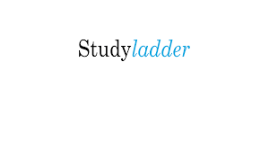 | Spellings  And Home Learning  Projects
Monday | Numbots | Shape | Writing | Science | Studyladder | Please practise the weekly spelling tasks and complete the project tasks that were sent home at the beginning of Spring 2.
Tuesday | Numbots | Shape | Writing | Science | Studyladder | Please practise the weekly spelling tasks and complete the project tasks that were sent home at the beginning of Spring 2.
Wednesday | Numbots | Shape | Writing | Science | Studyladder | Please practise the weekly spelling tasks and complete the project tasks that were sent home at the beginning of Spring 2.
Thursday | Numbots | Shape | Writing | Science | Studyladder | Please practise the weekly spelling tasks and complete the project tasks that were sent home at the beginning of Spring 2.
Friday | Numbots | Shape | Writing | Science | Studyladder | Please practise the weekly spelling tasks and complete the project tasks that were sent home at the beginning of Spring 2.

YEAR 2 REMOTE LEARNING 15.3.2021

